Day31 - Task14 - AWS CW & AWS CT for Monitoring

1. Enable CloudTrail monitoring and store the events in S3 and CloudWatch Logs

To capture every API call made inside our AWS account.
Examples:
- Launch EC2
- Stop EC2
- Delete S3 Bucket
- Create IAM User
- Attach Policy
- Login attempts
CloudTrail records everything.

Step 1: Open AWS Cloud Trail
- Open Cloud Trail Management Console
- Press Create Trail to create a new Trail, Select the below Cloud Trail Attributes
  - Name : demo-events-trail
  - Storage Location: Select ‘Create New S3 Bucket’ and leave the default name set by the console ‘aws-cloudtrail-logs-532025489581-10a78d94’
  - Note that some settings will be defaultly enabled by the AWS Console, like log file SSE-KMS encryption, log validation. Disable them for now
  - Cloud Watch Logs: This will also be defaultly enabled by the AWS Console, keep it as it is.
  - log-group-name: ‘aws-cloudtrail-logs-532025489581-d6ab67db’
  - IAM Role: ‘New’
  - Role name: demo-events-trail-monitor
- Now, press create, the console will continue to ‘Choose log events’ page, follow the below steps in this page
  - AWS Console defaultly chooses ‘Management Events’, keep it. We’ll explore other events(Data Events, Insight Events, Network Activity Events) in later tasks.
  - API Activity: Read & Write
- Review & Create
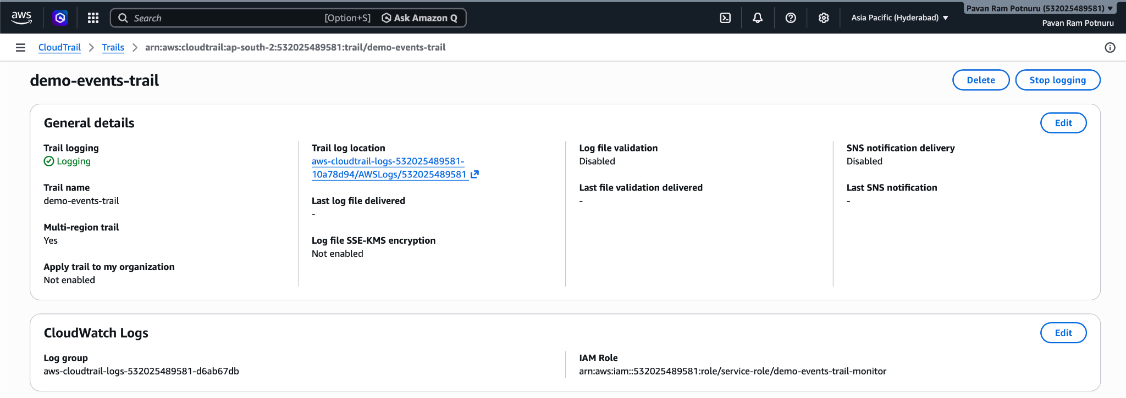
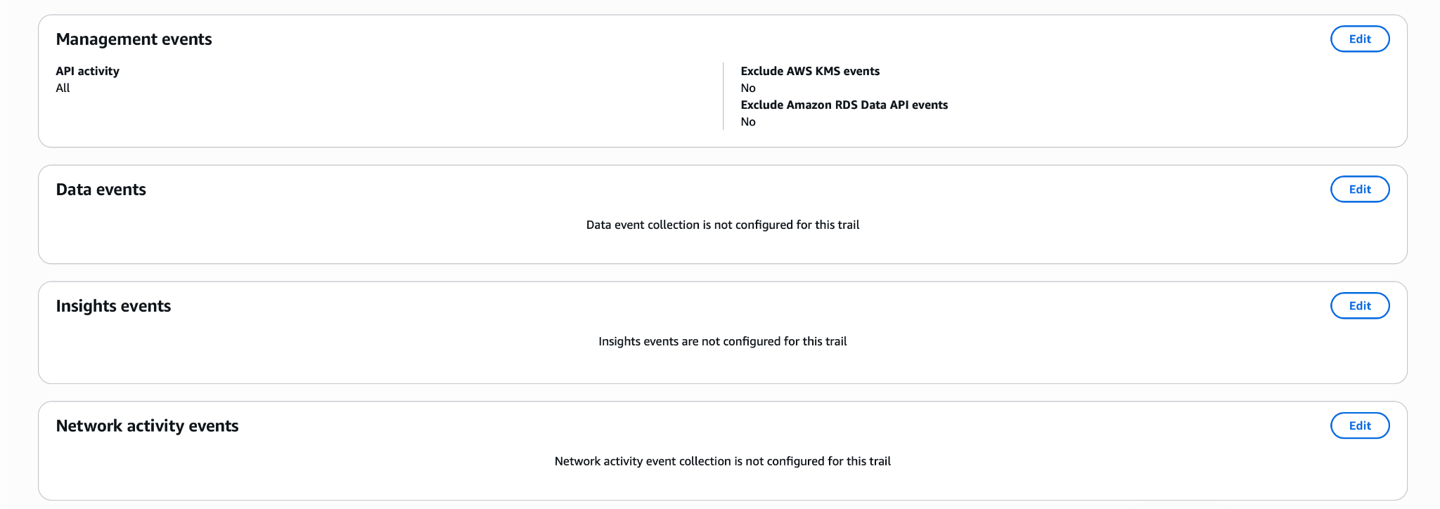

Step 2: Now follow the below steps to verify if the events are getting logged or not
- Open AWS EC2
  - Create a new instance
  - Use existing key-pair
  - Use existing security group
  - Once it is up and running, TERMINATE it!
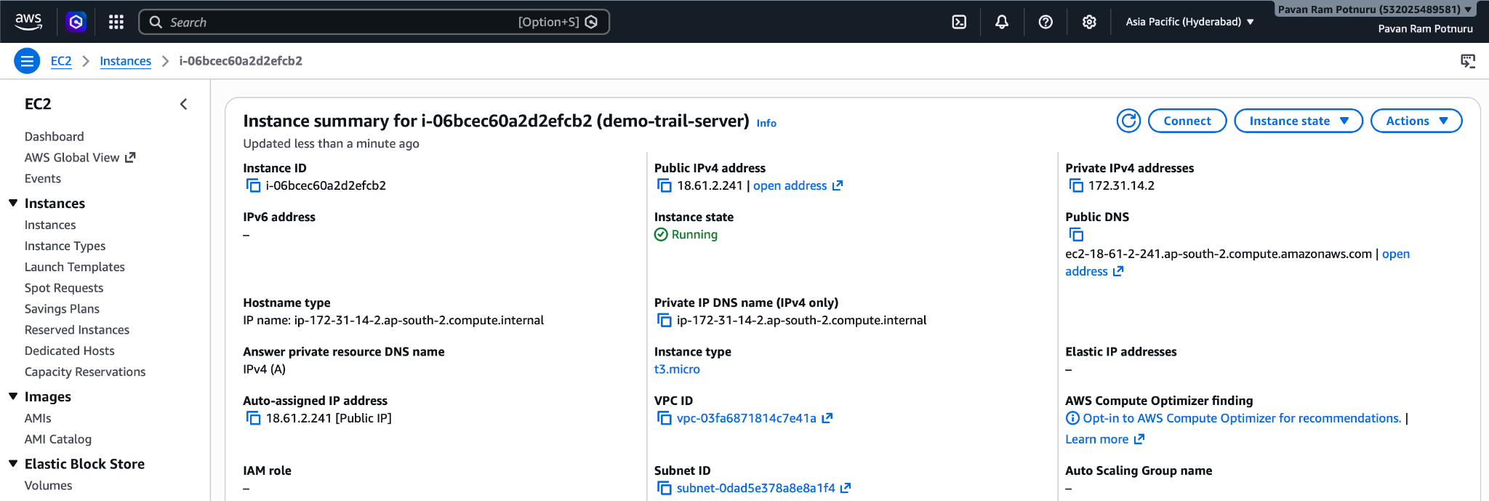

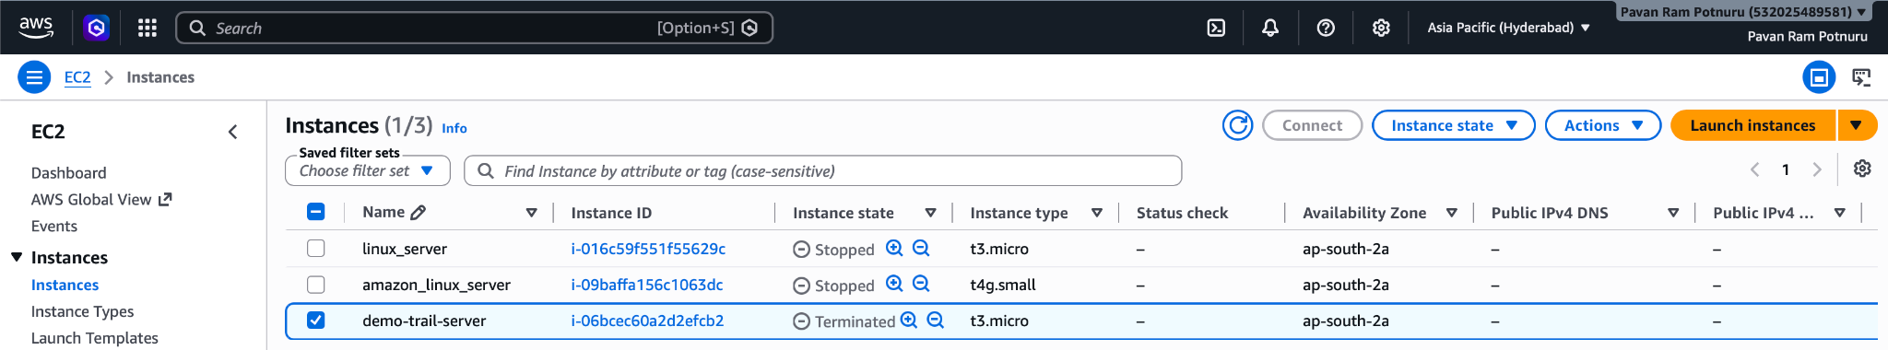
- Open AWS Security Group
  - Create a new SG with one Inbound Rule to allow Custom TCP connect from My-IP.
  - Once it is created, delete it!
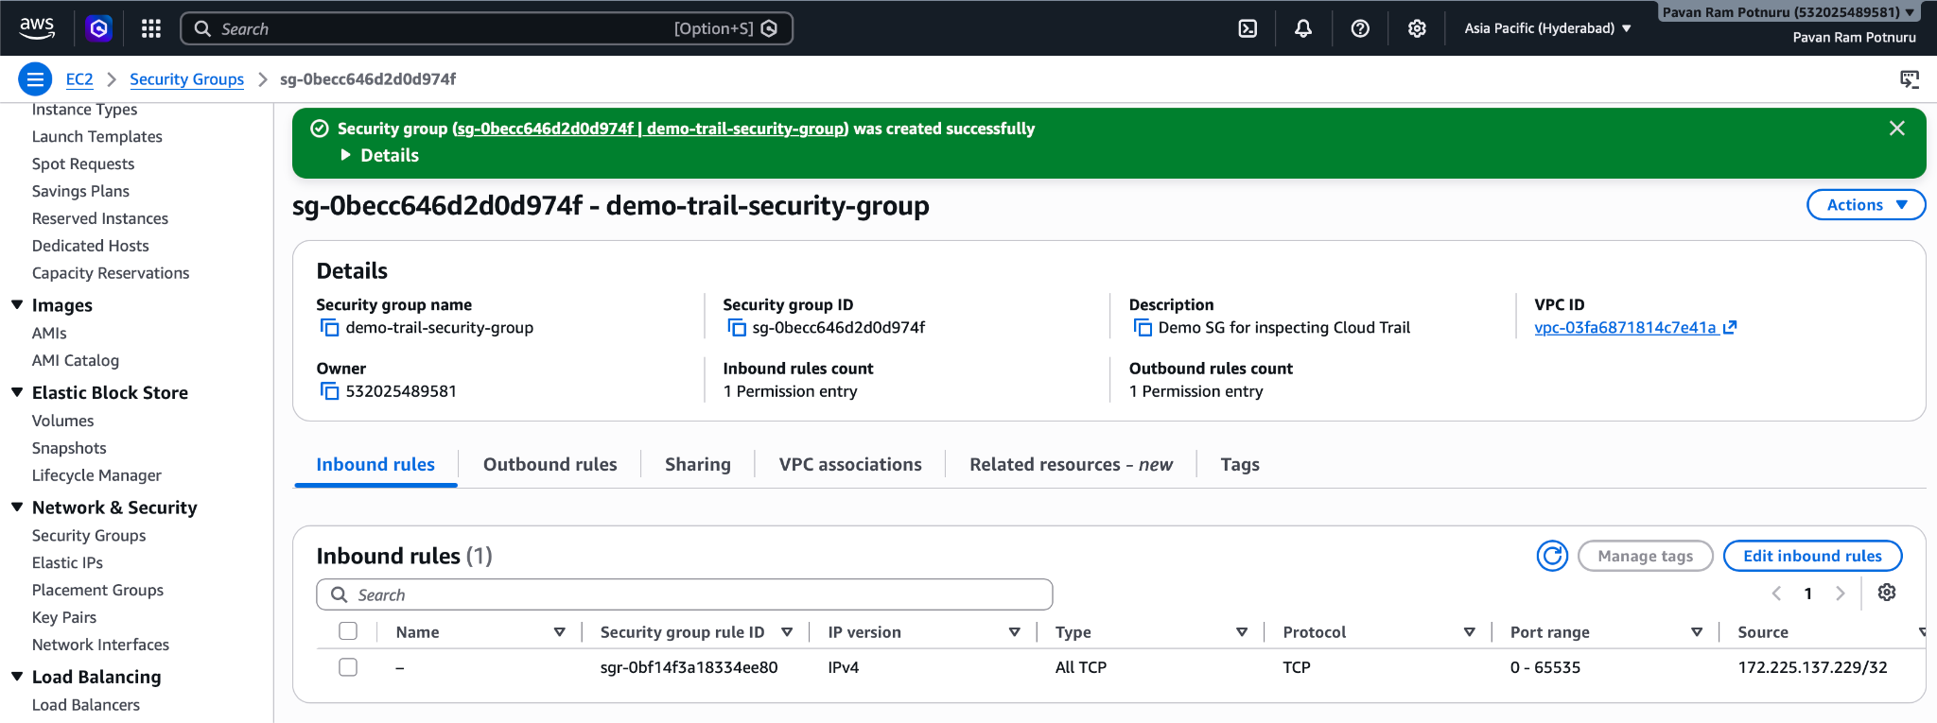

- Open AWS Cloud Trail
  - Open Events History, all the events performed by you among other services can be seen here

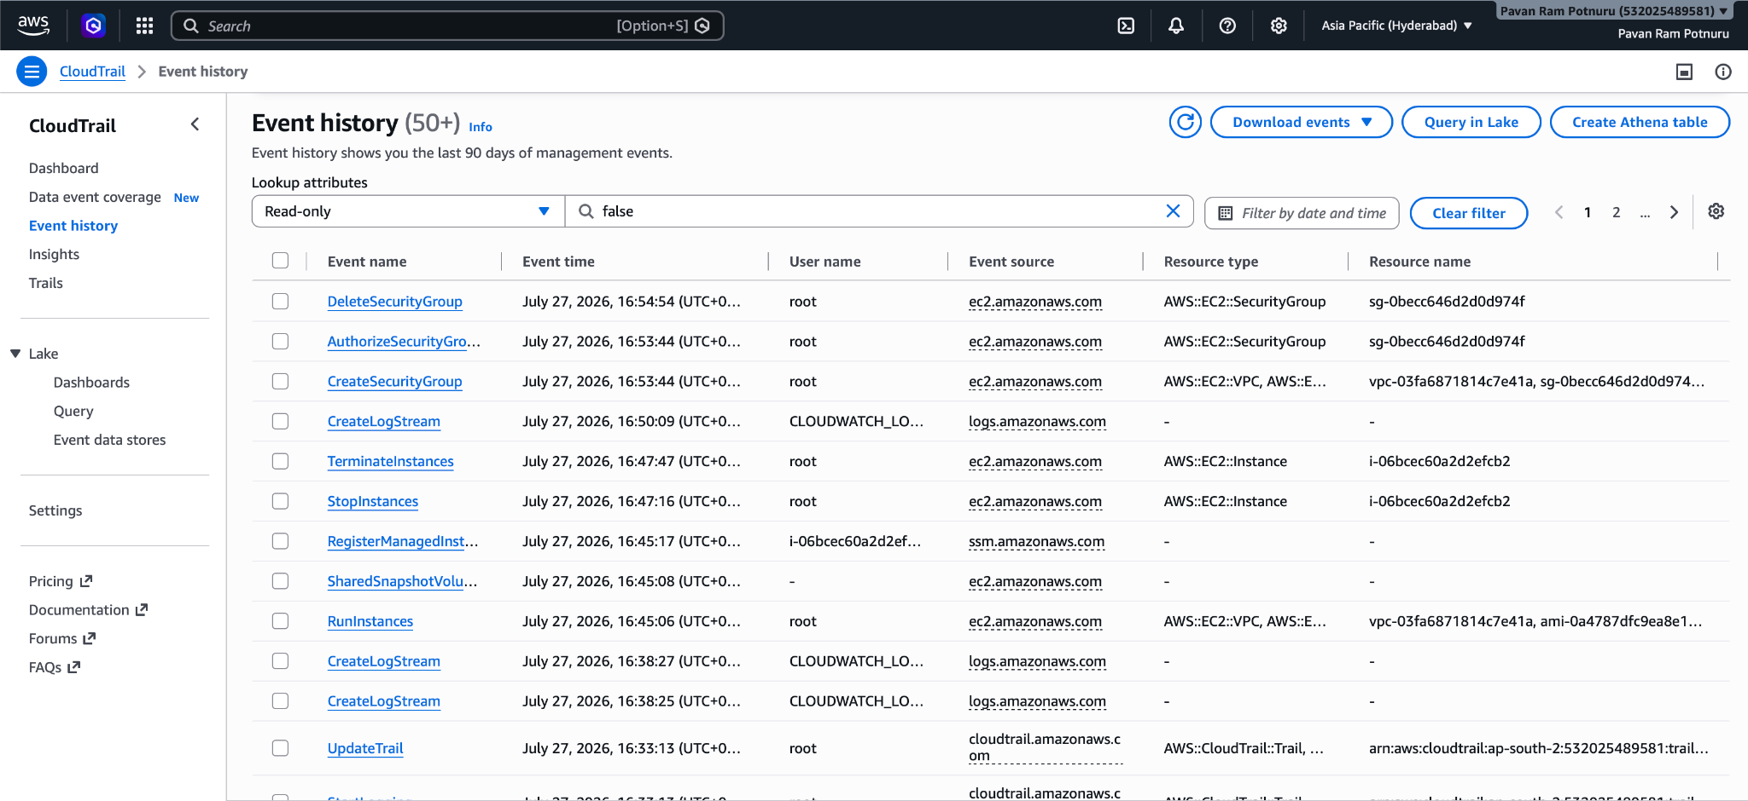

- Open AWS Cloud Trails Dashboard
  - Open demo-events-trail and select the uri present at Trail Log Location, this will re-direct to AWS S3 Bucket, if you open the aws-cloudtrail-logs-532… bucket, you can check all the chronically stored logs respective to their regions.
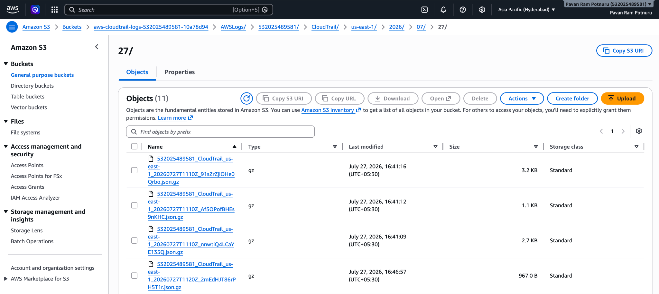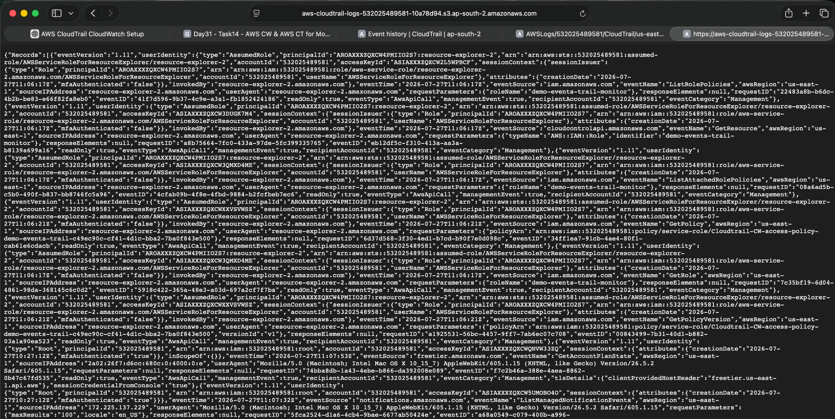

This is the background process that happens when a log is generated after an api-request
API Request
↓
CloudTrail receives API request
↓
Creates JSON Event
↓
Copies JSON into S3
↓
Copies same event into CloudWatch Logs
↓
CloudWatch can trigger Alarms
2. Enable SNS for CloudTrail Alerts

To receive an email when important CloudTrail events occur.

Step 1: Open SNS
- Create a Topic
  - Name: ‘cloud-trail-alert’
  - Select Standard type
  - Leave all the remaining settings in default and press ‘create topic’
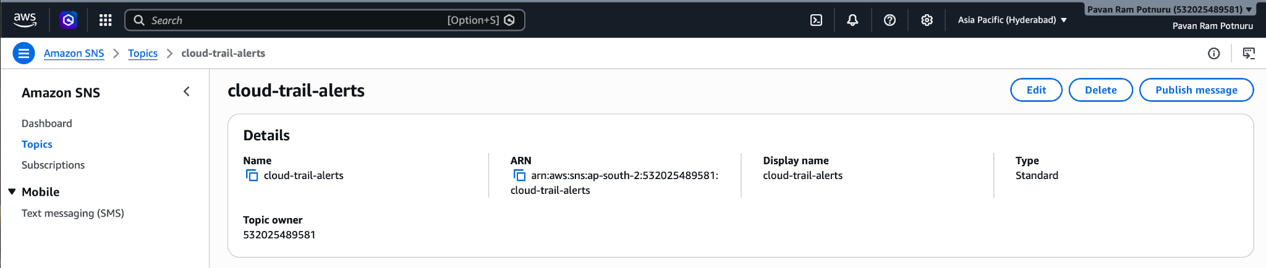

- Now Create a Subscription
  - Protocol: Email
  - Endpoint: pavanram.potnuru@gmail.com/<your email>
  - Open Gmail, sign-in to your email and you will see a AWS Notification asking to confirm your email for subscription.
  - Open it and Confirm.
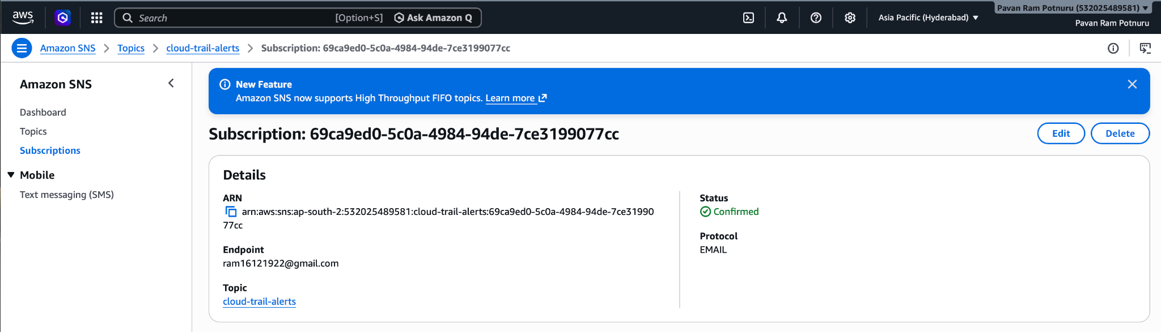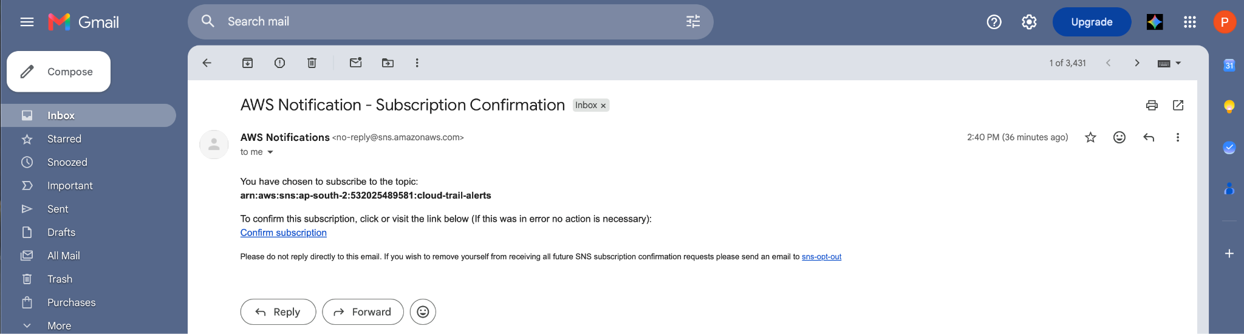
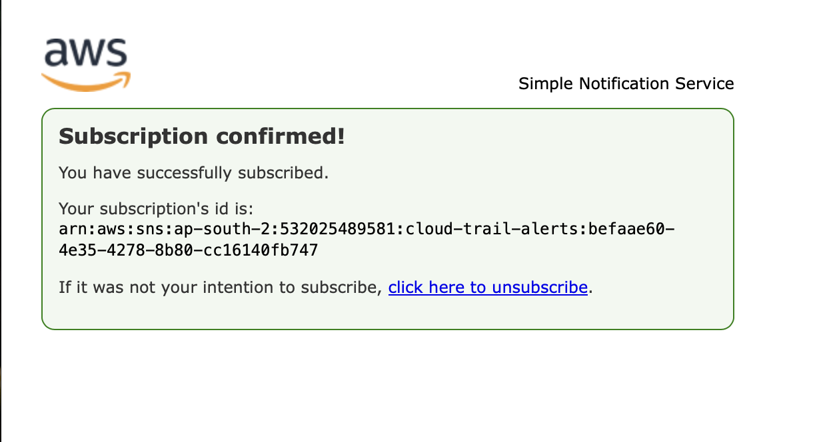
Step 2: Create a Metric Filter for the previously configured Cloud Watch Log Group
- Open Cloud Watch -> Logs
  - Open the Log Group: aws-cloudtrail-logs-532025489581-d6ab67db
  - In the below menu bar, Select Metric Filters
  - Select Create New Metric Filter
  - Set this pattern: { ($.eventName = "ConsoleLogin") && ($.responseElements.ConsoleLogin = "Success") }
  - Click ‘Next’, this opens the next page to configure the metric
  - Use the below values in their respective fields
Field | Value
Filter name | ConsoleLoginFilter
Metric namespace | CloudTrailMetrics
Metric name | SuccessfulConsoleLogins
Metric value | 1
Default value | 0 (if the console asks for it)

  - Now click ‘Next’, Review the configuration and select ‘Create’
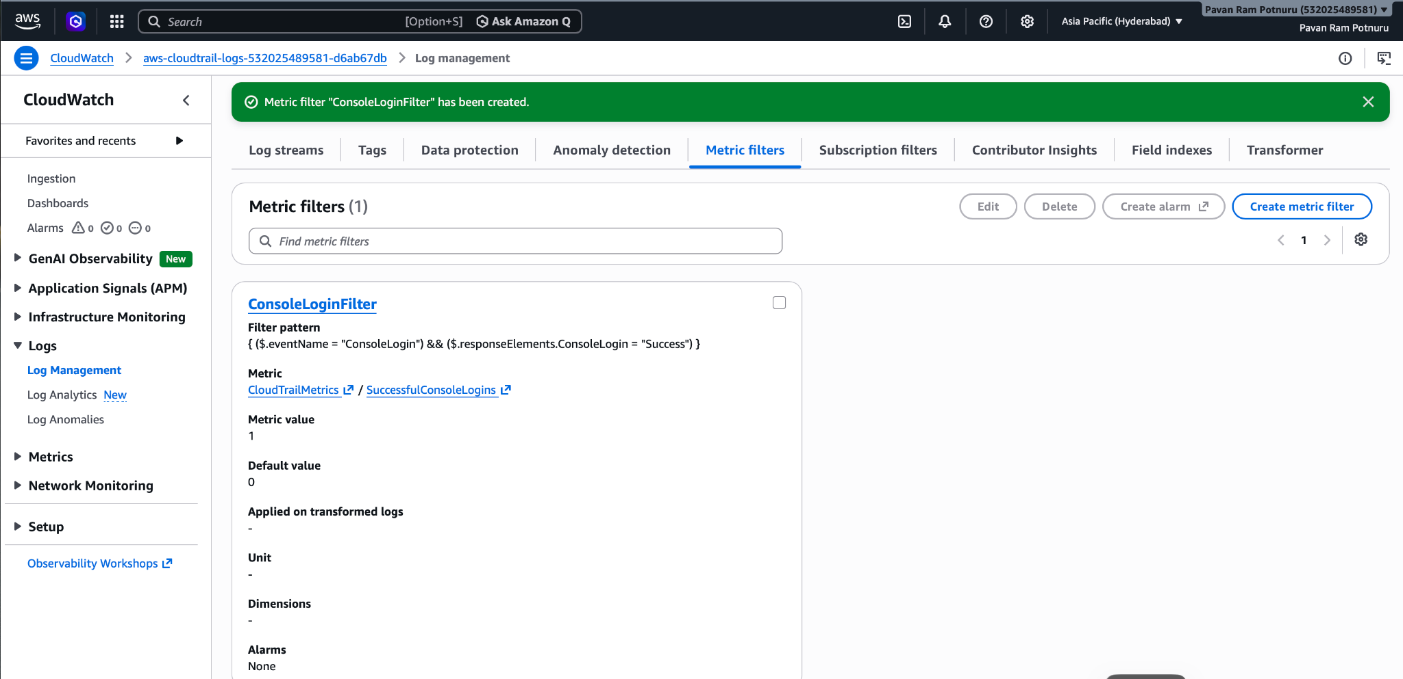
Step 3: Create a Cloud Watch Alarm
- Go to Cloud Watch -> Alarms
  - Select ‘Create Alarm’
  - Then it asks to Select ‘Metric’
  - Navigate to ‘SuccessfulConsoleLogins’ from Cloud Trail Metrics -> Metrics with no Dimensions and select it.
  - Configure the alarm with below values in respective fields
Setting | Value
Statistic | Sum
Period | 5 minutes
Threshold type | Static
Whenever metric is | Greater than or equal to
Threshold value | 1

  - Select ‘Next’ and configure the Notifications using below values
  - Choose
    - In alarm
    - Select an existing SNS topic
  - Choose the ‘cloud-trail-alerts’ SNS topic from the dropdown and click ‘Next’
  - In the next step, name the alarm, and add description
    - Name: ConsoleLoginAlarm
    - Desc: Alert when a successful AWS Console login is detected.
  - Now click ‘Next’ -> Preview the Alarm Configuration and click ‘Create’
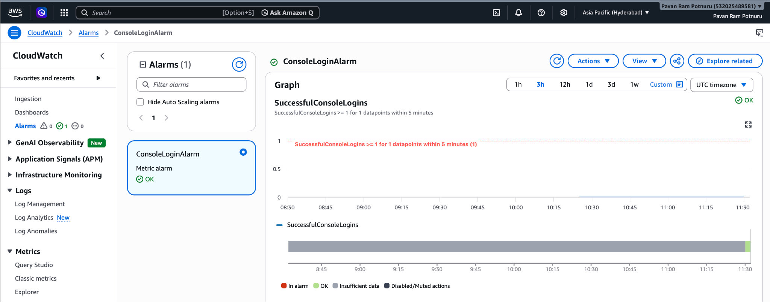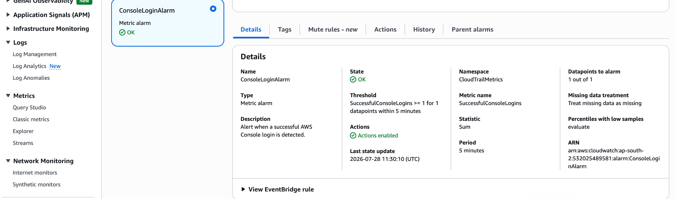
- Now to verify the alarm, perform the below steps
  - Sign-out of AWS Management Console
  - Again, sign-in into your root account
  - Wait for 2-5mins
- Open Cloud Trail -> Event History, clear all filters and check for Console Logins in N.Virginia region, you’ll see a record showing your Login Details
Note: AWS Security Checks are all recorded and treated as Global Services, rather than a regional service. Since the Console Login event is a standard AWS Security check, the api call and log will be created in its default global region i.e., N.Virginia
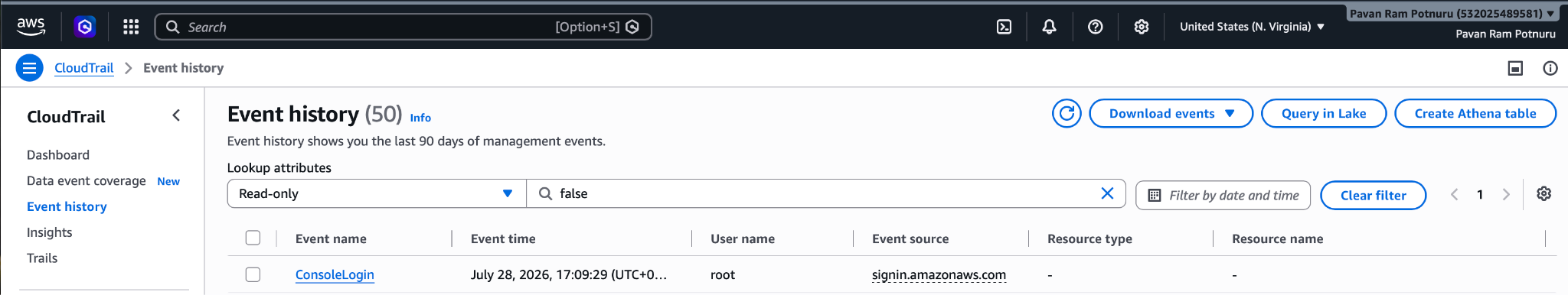
- Open Cloud Watch -> Alarms, you’ll see the Cloud Trail Dashboard showing a spike when you logged-in into your AWS Management Console, During that spike period the status of alarm changes to ‘In Alarm’
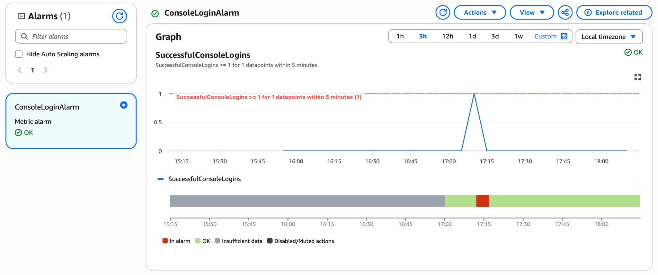
- During the spike period, Cloud Watch performs the SNS service and you’ll receive an alert email
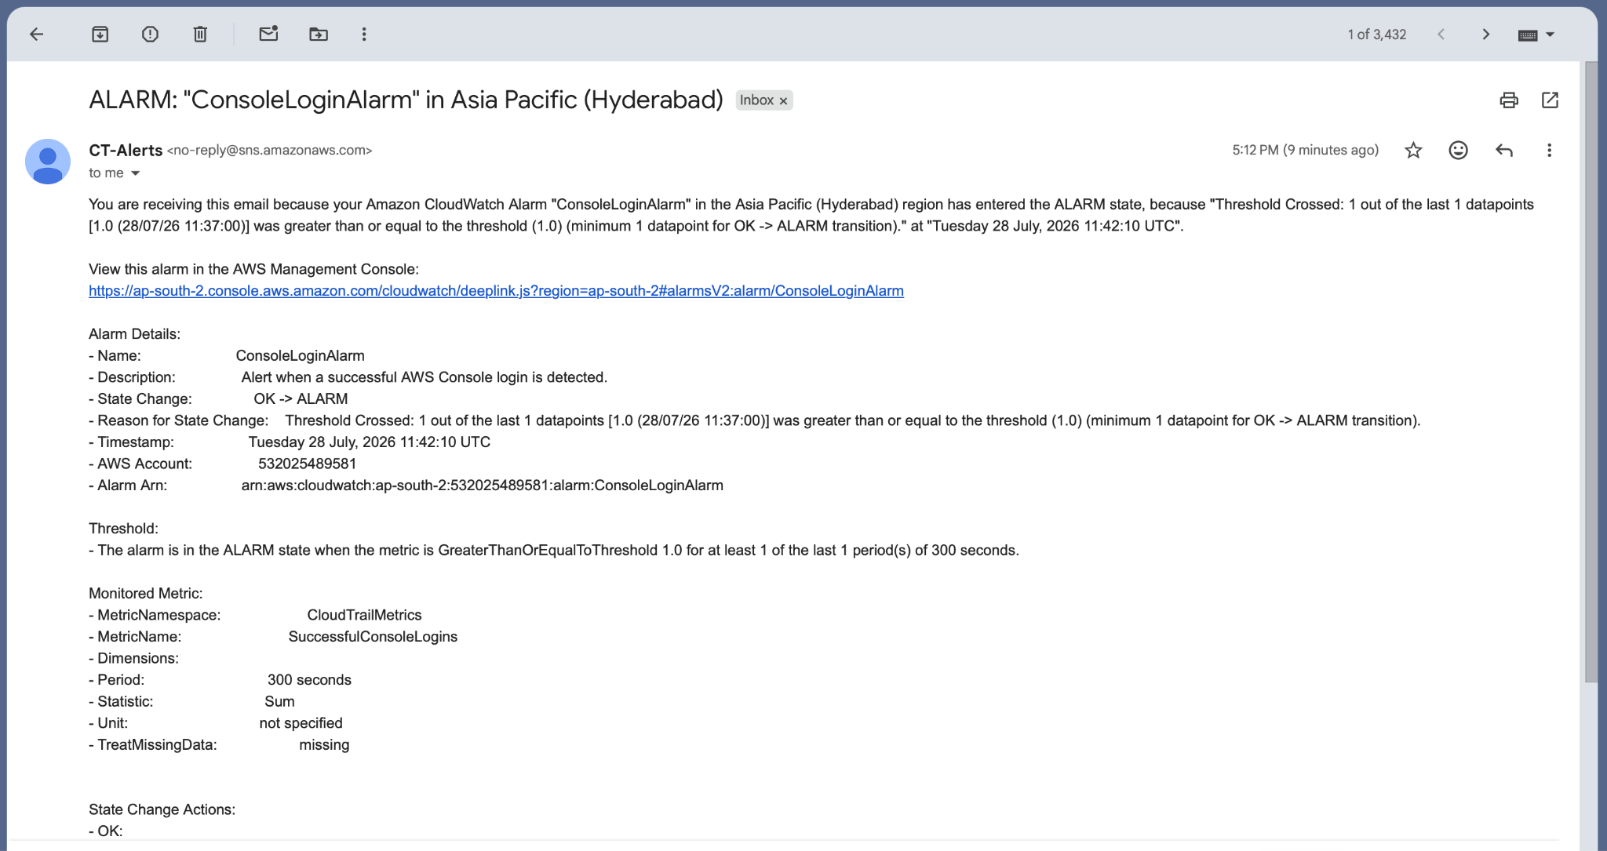
Note 1: In real production environments, organizations often create alarms for events like:
- Root user login
- TerminateInstances (EC2 termination)
- DeleteBucket (S3 bucket deletion)
- IAM user or policy changes
- Security group modifications
- Failed console login attempts
These provide security teams with immediate visibility into important account activity.

Note 2: The AWS Management Console sign-in process uses a global authentication service. CloudTrail records ConsoleLoginevents for that global service in us-east-1 (N. Virginia). Regional service events, such as EC2 or RDS operations, are recorded in the region where those resources exist.
Note 3: IAM and the AWS Management Console authentication process are global services. Console login events are associated with AWS's global sign-in infrastructure, so CloudTrail commonly records ConsoleLogin events in us-east-1. Regional services like EC2, VPC, and RDS record their API activity in the region where the resources exist.

There are two broad categories of AWS services:

🌍 Global Services
- IAM
- AWS Organizations
- CloudFront
- Route 53
- AWS Sign-In
- IAM Identity Center (authentication)
🌏 Regional Services
- EC2
- VPC
- EBS
- RDS
- ECS
- EKS
- Lambda
- CloudWatch
- SNS
- SQS

Understanding global vs. regional services is one of the most important AWS concepts. It explains why resources appear in different regions, why some services don't have a region selector, and why CloudTrail events are distributed the way they are. It's a topic that comes up frequently in AWS interviews and in day-to-day cloud operations.

Task 3 – Monitor EC2 Metrics Using CloudWatch

View EC2 performance metrics. Understand what each metric means. Create graphs. Create a CloudWatch Dashboard. Create alarms for CPU utilization.

Step 1: Checkout the metrics defaultly setup by AWS for an existing EC2 Instance
- Open and existing EC2 Instance and open the monitoring tab, you’ll see graphs such as:
  - CPU Utilization - This is the percentage of CPU currently being used.
  - Network In - This shows the amount of data received by the EC2 instance.
  - Network Out - This measures the data sent out from the EC2 instance.
  - Status Check - Here AWS check for System Status Check(Hardware, Network, Power, Hypervisor) and Infrastructure Status Check(Kernel, Boot Process, Network Configuration)
  - Disk Read Bytes - Shows how much data the EC2 reads from its attached EBS volume.
  - Disk Write Bytes - Whenever your application writes to disk, the disk write byte increases
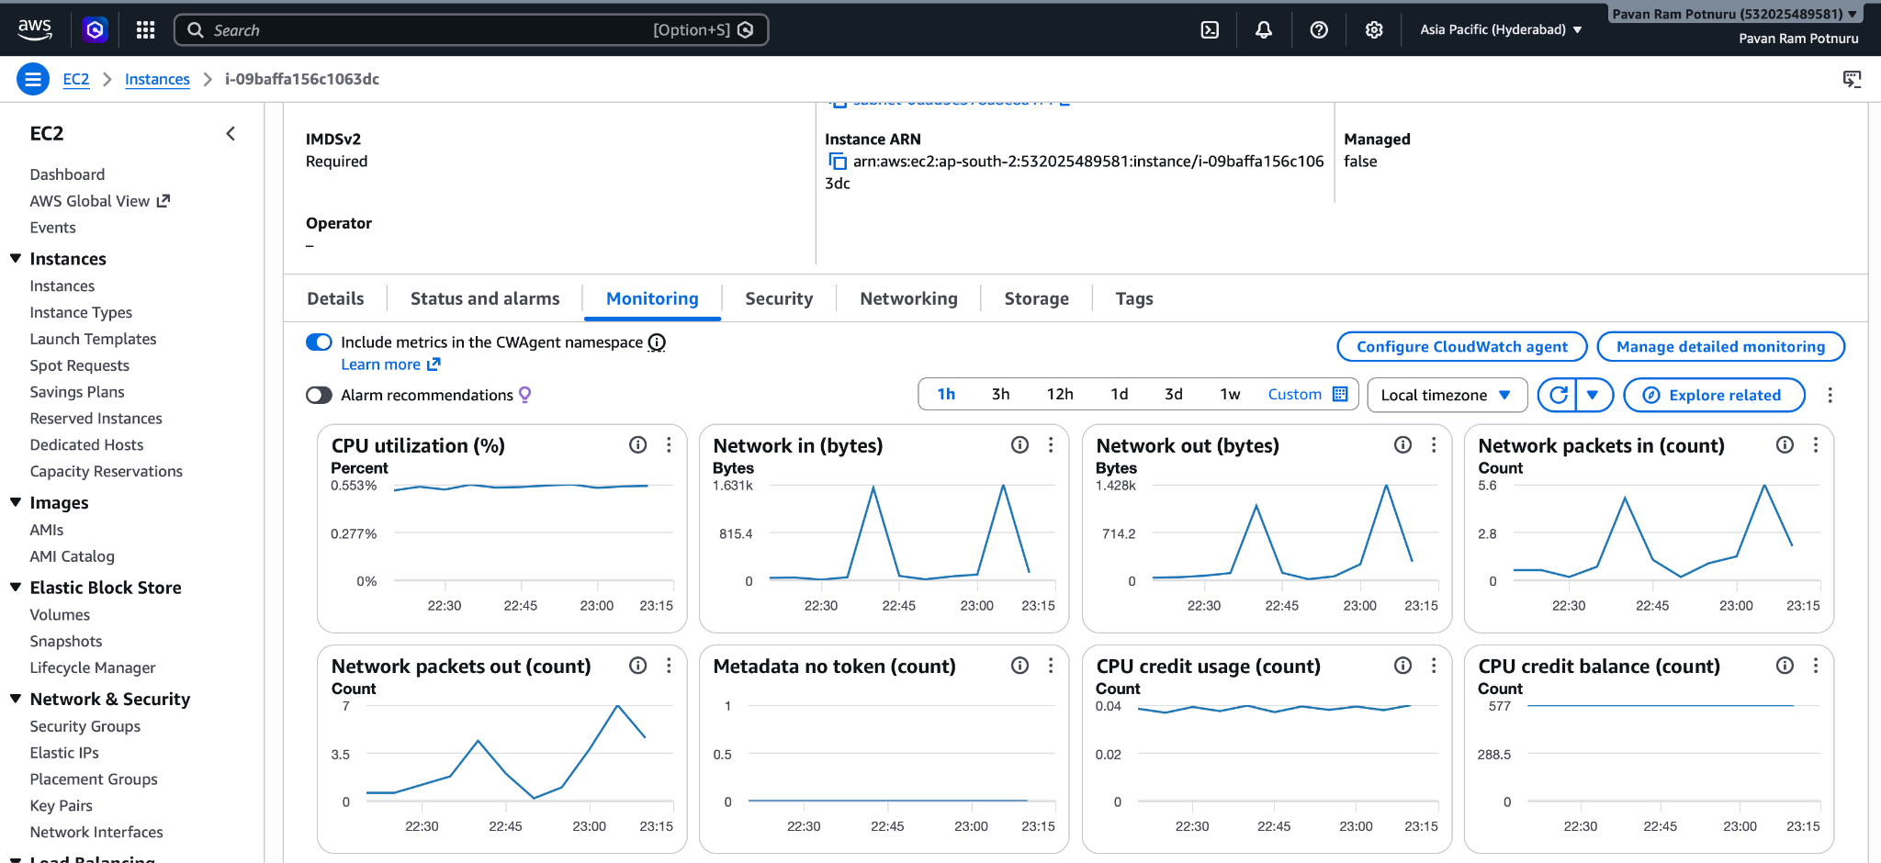

Step 2: Open Cloud Watch, explore and create a dashboard with some selected metrics
- Open Cloud Watch -> (on the side nav) Classic Metrics -> All -> EC2 -> Per-Instance Metrics
  - Once you open that tab, you’ll see a list of metrics beside the name of all the instances you have created.
  - About 22 metrics can be seen for each instance.
  - Select one instance and select all the metrics(22) that instance is defaultly providing
  - Every metric will be added to the graph presented above. It will look like this..
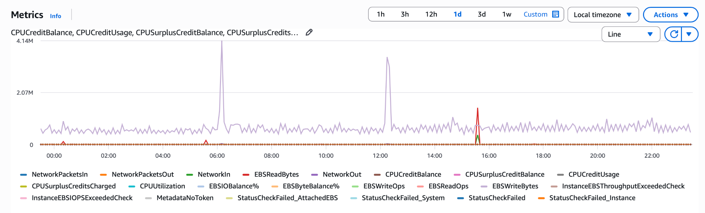

- Select the below metrics to create a dashboard for your EC2 Instance
  - CPUUtilization
  - NetworkIn
  - NetworkOut
  - DiskReadBytes
  - DiskWriteBytes
- Once selected, in the top right corner you’ll see ‘Actions’, click it..
  - In the dropdown, select ‘Add to Dashboard’, a form will open
  - Dashboard Name: Amazon-Linux-Machine-Monitoring-Dashboard
  - Click ‘Create New’
  - Now in the form itself select the dashboard from the search dropdown
  - Widget Type: Line
  - Now click ‘Add to Dashboard’. This will redirect to the dashboard window for resizing your board, resize it to your desired ratio and hit save on the top panel.
  - You can club different dashboards with different metrics to this cloud watch dashboard
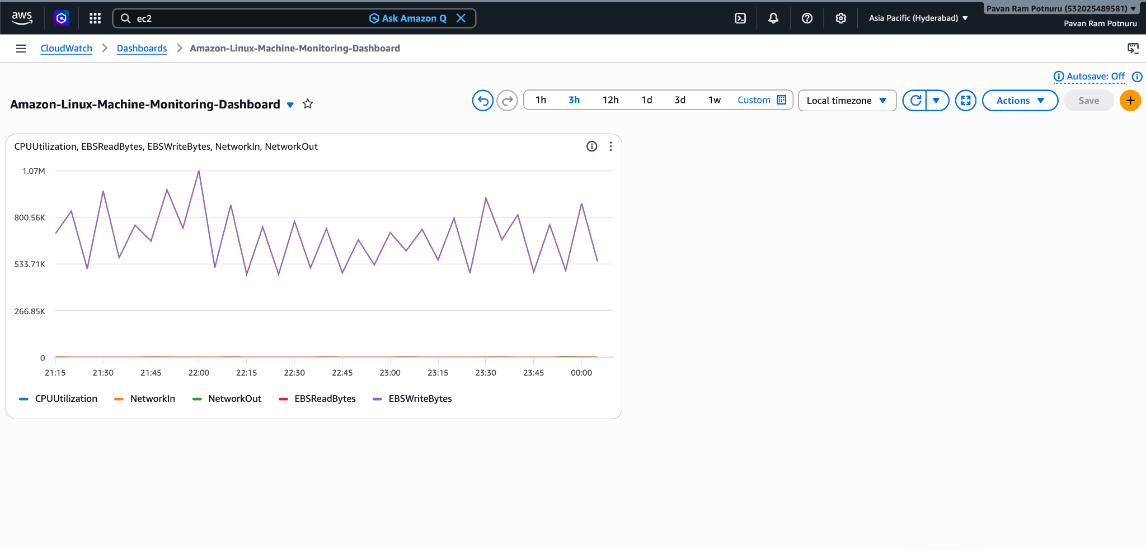
Task 4 - Create one alarm to send an alert to email if the CPU utilization is more than 70 percent.

Step 1: Create an alarm for the existing EC2 Instance’s CPU Utilization
- Open Cloud Watch -> Classic Metrics -> All -> EC2 -> Per-Instance Metrics
  - Select the checkbox for CPU-Utilization for your desired ec2 instance
  - Select ‘Create Alarm’ in the top panel of the metric table page
  - Keep all the defaults as is in the Data Source, Type, Metric pane
  - In the Conditions pane, leave defaults for threshold type and the operator
  - Edit the threshold value to 50 and click ‘Next’
  - Now in the Configure Actions page, Notifications pane, leave the alarm state trigger in ‘In Alarm’
  - In the below dropdown select the existing SNS Topic: cloud-trail-alerts
  - Now click ‘Next’
  - Set Name: Amazon-Linux-Machine-HighCPU-Alarm and click ‘Next’
  - Now, review the configuration and click ‘Create Alarm’
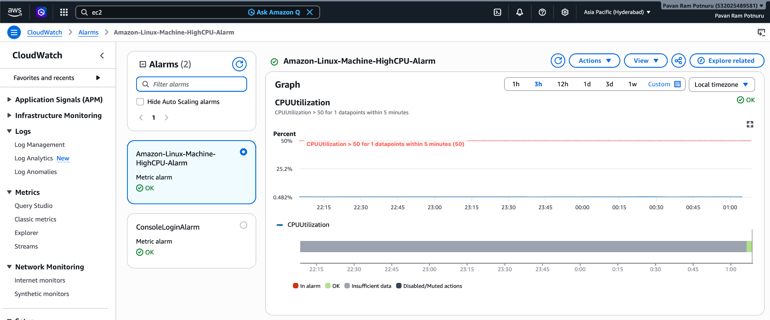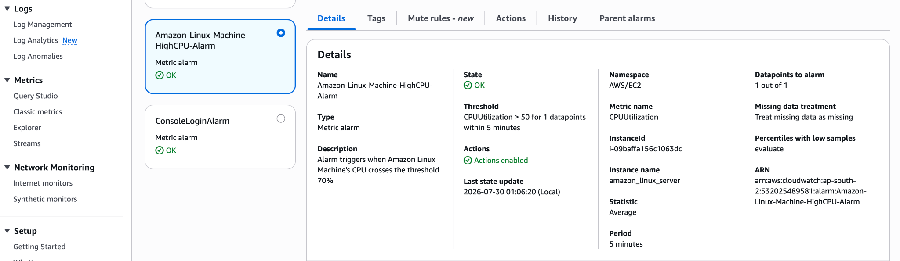
Step 4: Verify the alarm is triggering when the CPU Utilization reaches 50%
- Connect to your EC2 Instance and run the below command multiple times
  - Command - yes > /dev/null & - This command continuously generates output and discards it, consuming CPU.
  - Wait for 5-10mins, then run the Command - pkill yes - This will kill all the processes and the CPU Utilization will climb down.
  - During this time, our cloud watch alarm triggers and sends us mail.
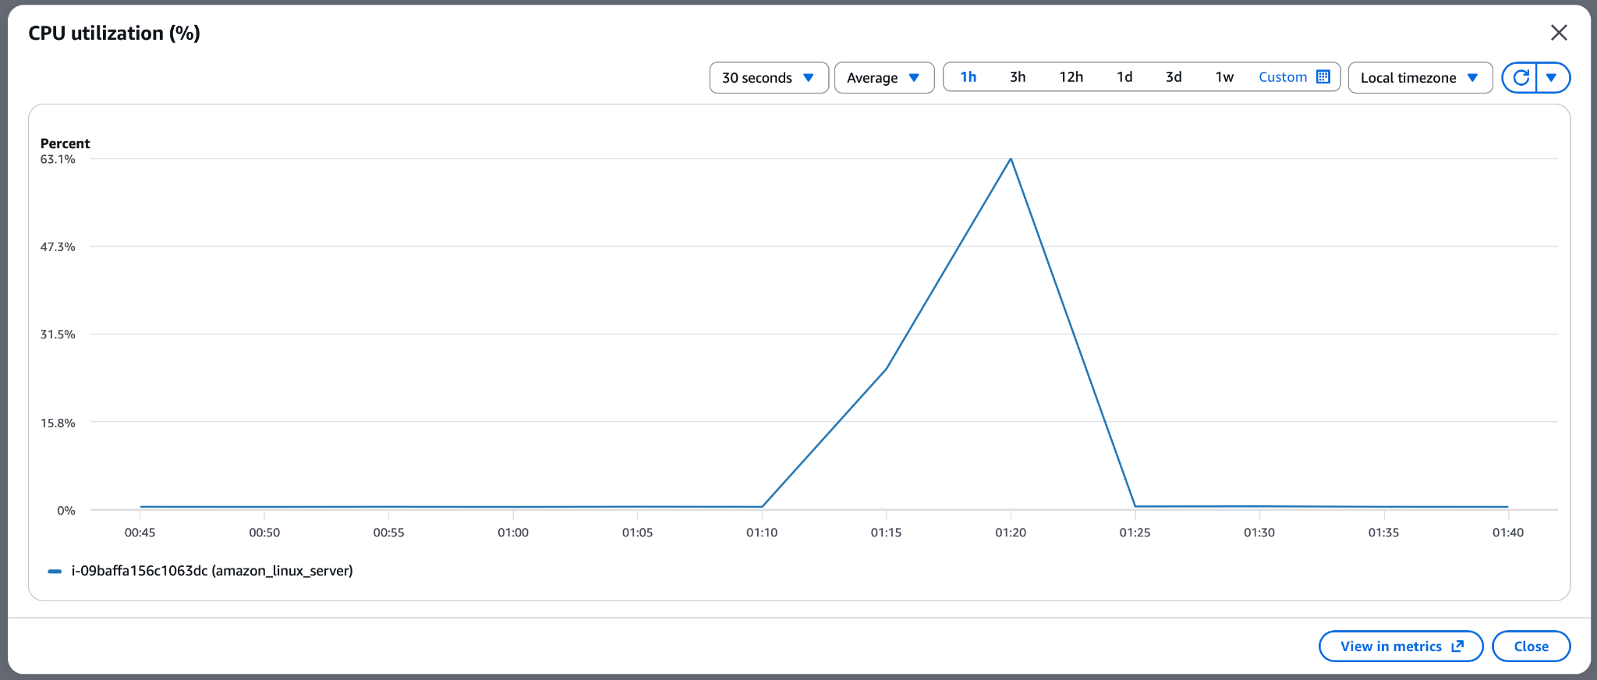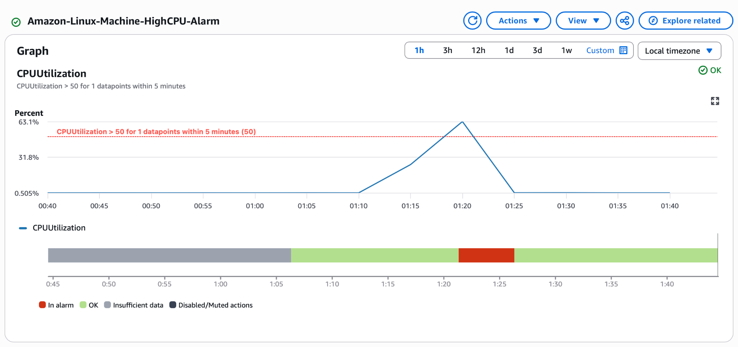
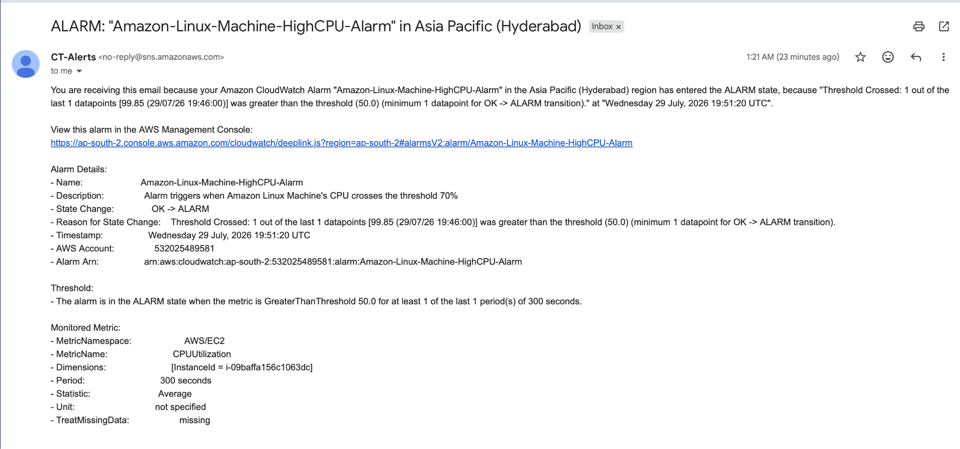
Task 5: Create a Dashboard and Monitor the Tomcat Service

Monitor the Tomcat service on an EC2 instance and send an email alert if the service stops.

Step 1: Login into your EC2 Instance and Verify Tomcat is Running
- Run the following commands
  - sudo systemctl status tomcat - Active: active (running)
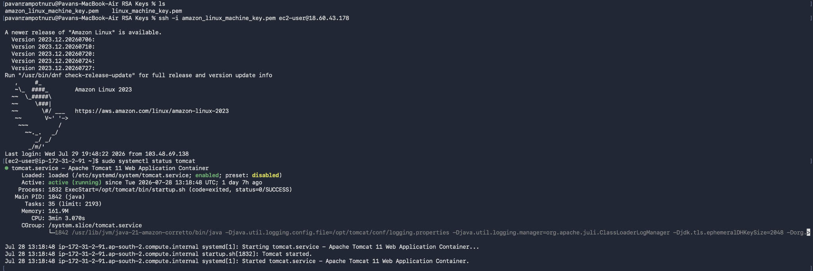

Step 2: Install the CloudWatch Agent
- Run the following commands
  - sudo yum install amazon-cloudwatch-agent -y
  - amazon-cloudwatch-agent-ctl -a status
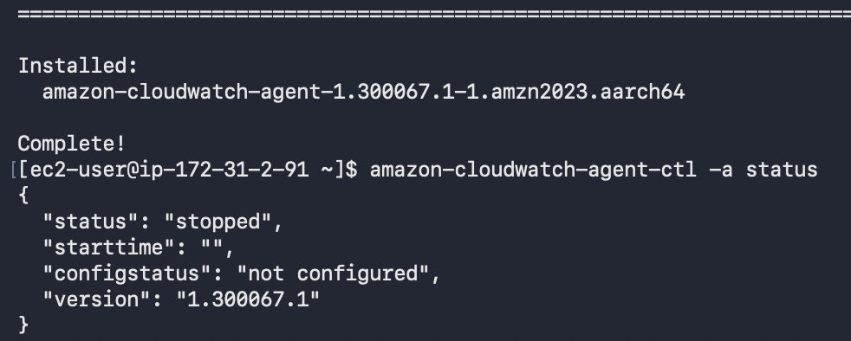
Note: Initially, it may show stopped until it's configured.

Step 3: Create the Agent Configuration
- Run the following commands
  - Create the configuration directory: sudo mkdir -p /opt/aws/amazon-cloudwatch-agent/etc/
  - Create the configuration file: sudo nano /opt/aws/amazon-cloudwatch-agent/etc/amazon-cloudwatch-agent.json
  - Paste the following and save the file:
{
"agent": {
"metrics_collection_interval": 60
},
"metrics": {
"namespace": "CWAgent",
"metrics_collected": {
"procstat": [
{
"pattern": "tomcat",
"measurement": [
"pid_count"
]
}
]
}
}
}
Step 4: Start the CloudWatch Agent
- Run the following commands
  - sudo /opt/aws/amazon-cloudwatch-agent/bin/amazon-cloudwatch-agent-ctl \
-a fetch-config \
-m ec2 \
-c file:/opt/aws/amazon-cloudwatch-agent/etc/amazon-cloudwatch-agent.json \
-s
  - Check its status - sudo /opt/aws/amazon-cloudwatch-agent/bin/amazon-cloudwatch-agent-ctl -a status
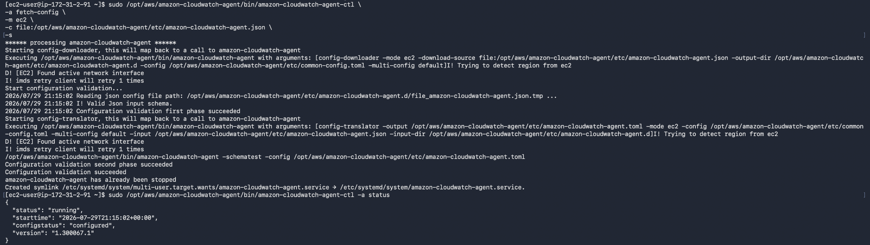
Step 5: Verify the Metric
- Wait for 5mins, Open AWS Management Console and Navigate to CloudWatch -> Classic Metrics -> CW Agents
  - You’ll not see CW Agents Namespace
  - If you don't see the CWAgent namespace, it means the CloudWatch Agent is not successfully publishing metrics yet.
  - We need to configure an IAM Role and the role needs the CloudWatchAgentServerPolicy policy attached.
  - If no IAM role is attached to your EC2 Instance, the CloudWatch Agent cannot send metrics to CloudWatch.
Step 6: Attach ‘CloudWatchAgentServerPolicy’ policy to an IAM Role
- Create an IAM Role
  - AWS IAM -> Roles -> Create Role
  - Choose -> Trusted Entity: AWS Service
  - Service: EC2 and click ‘Next’
  - Search for CloudWatchAgentServerPolicy and select it
Note: This policy gives the agent permission to:
- Publish metrics to CloudWatch
- Publish custom metrics
- Send log files (if configured)
- Retrieve certain configuration information
  - Click ‘Next’
  - Name: ‘EC2-CloudWatch-Agent-Role’
  - Click ‘Create Role’
Step 7: Attach the Role to Your EC2 Instance
- Open EC2
  - Select the desired EC2 Instance -> Actions -> Security -> Modify IAM Role
  - Choose the IAM Role we just created: EC2-CloudWatch-Agent-Role
  - Click ‘Update IAM Role’
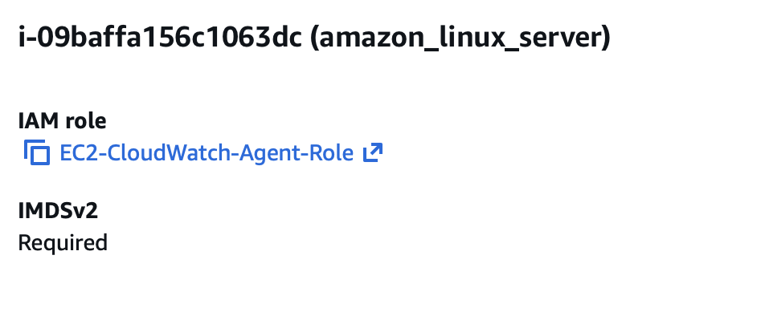
Step 8: Now, verify the metric
- Wait for 5mins, Open AWS Management Console and Navigate to CloudWatch -> Classic Metrics -> All -> CW Agents -> host, patter, pid_finder
  - Select the metric with the name ‘procstat_lookup_pid_count’
  - Check the graph above.
    - Tomcat Running: 1
    - Tomcat in-active: 0
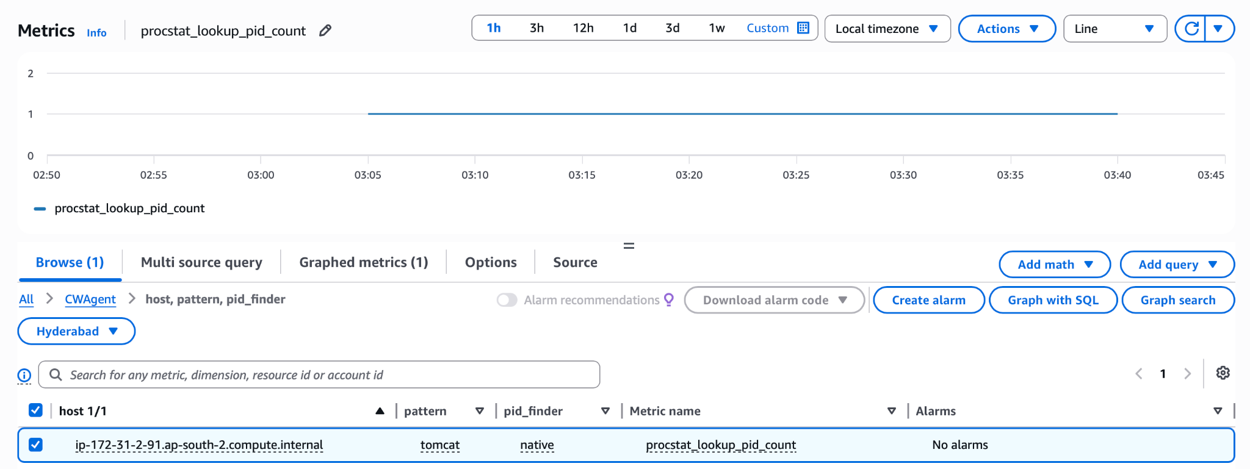

Step 9: Create Dashboard and an Alarm
- Cloud Watch -> Dashboards -> Create Dashboard
  - Name: Tomcat-Monitoring-Dashboard
  - Add the metric: CW Agent -> procstat -> procstat_lookup_pid_count
  - Now ‘Save’ it.
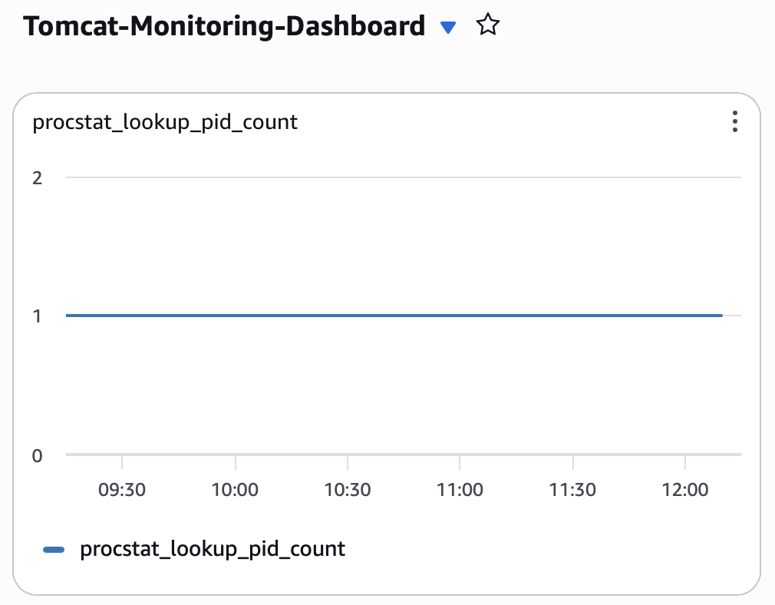
- Cloud Watch -> Alarms-> Create Alarms
  - Select CW Agent -> procstat_lookup_pid_count
  - Configure like this…

Setting | Value
Statistic | Average
Period | 1 Minute
Threshold | Less than 1
Evaluation Periods | 1
Missing Data | Treat as missing (default is fine for this lab)
SNS Topic | Existing Topic

  - Name: Tomcat-Service-Down
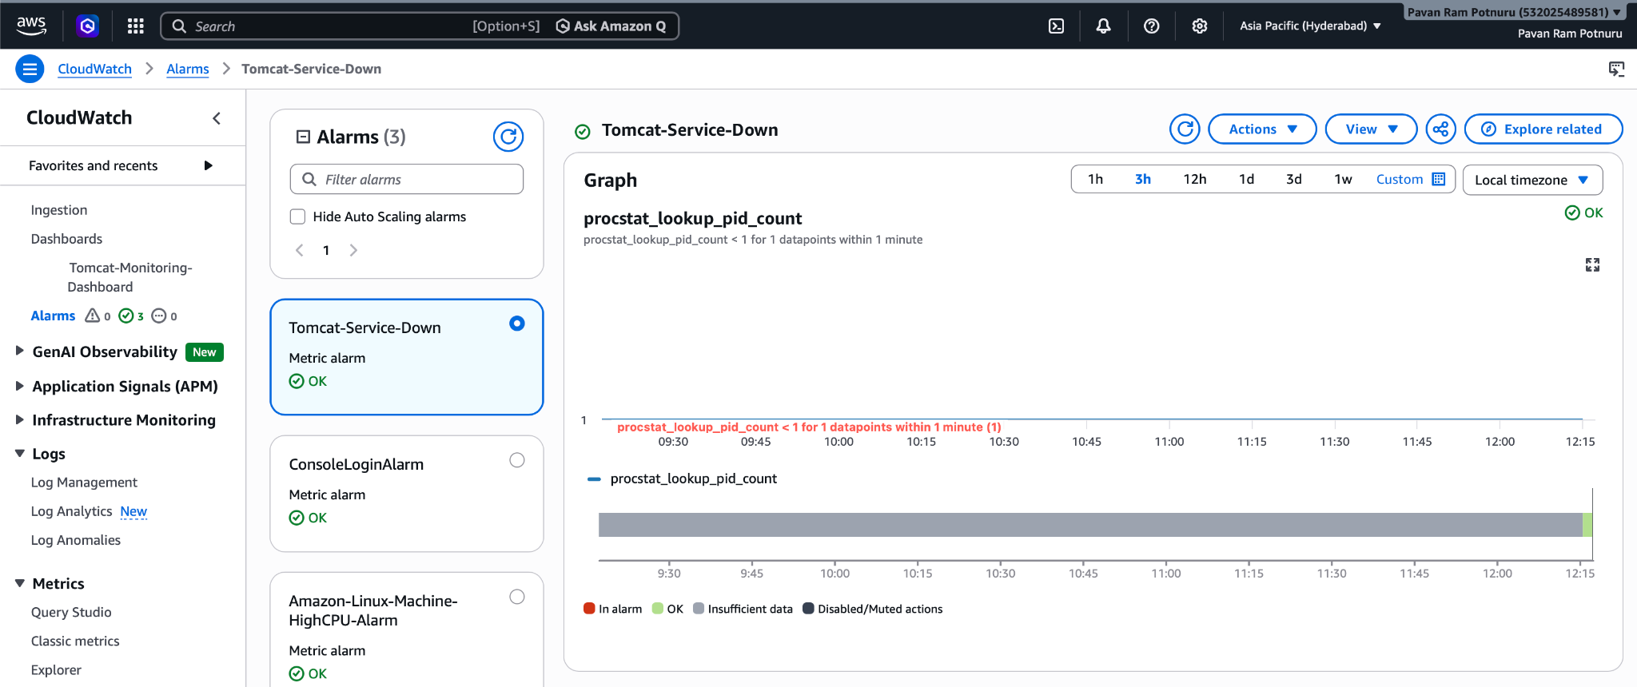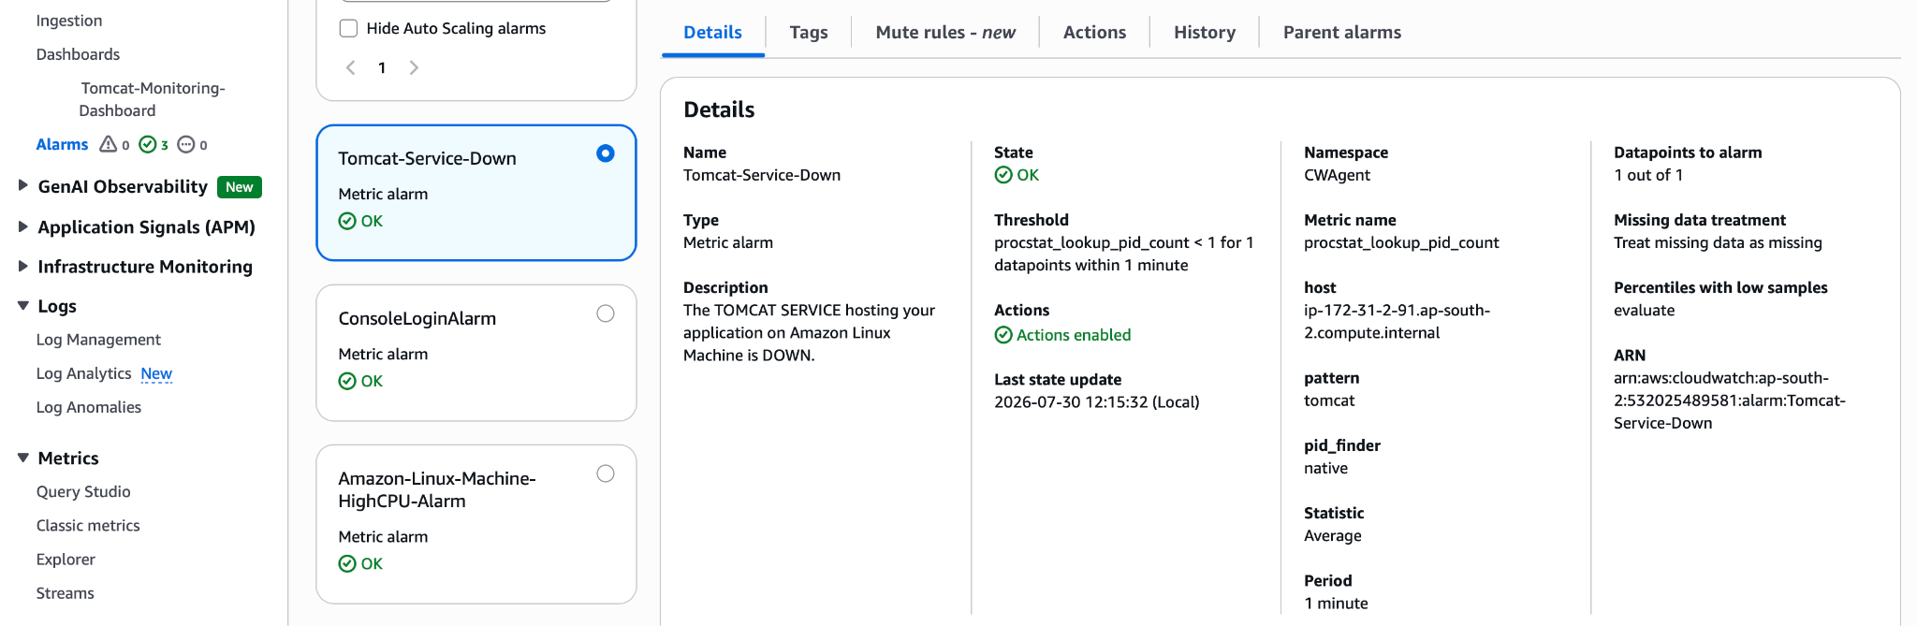
- Test it by running the below command
  - Sudo systemctl stop tomcat
  - You’ll receive an email saying…
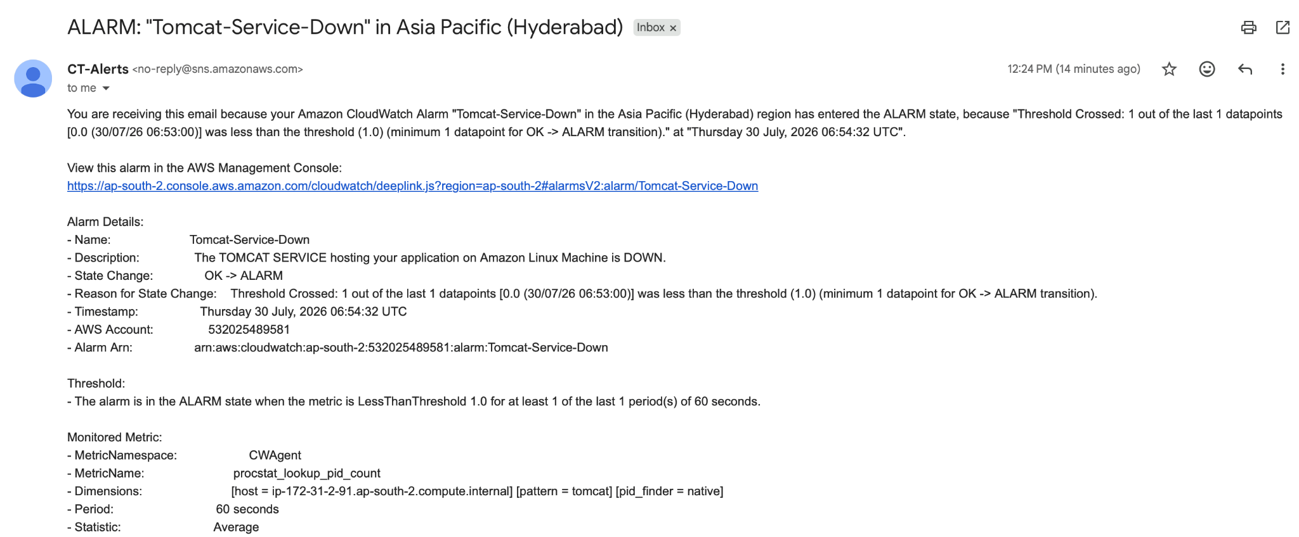
- Check the below graph for tomcat-service-downtime
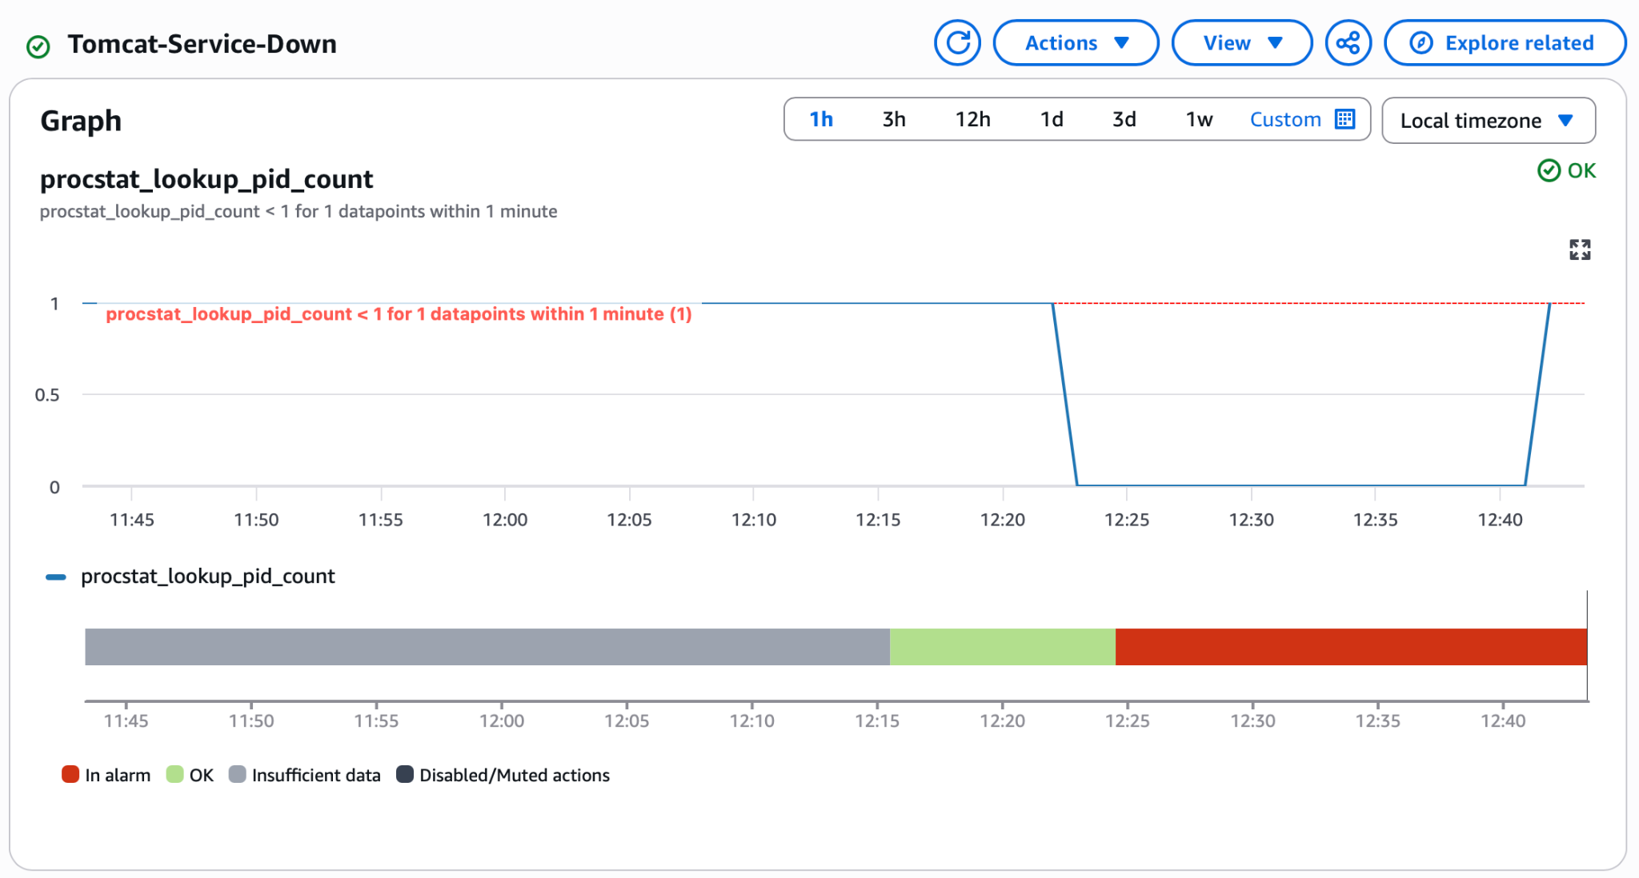

Task 6 – Create a Dashboard and Monitor the Nginx Service

Monitor the Nginx service and send an email notification if it stops.

Step 1: Login into your EC2 Instance and Verify nginx is Running
- Run the following commands
  - sudo systemctl status nginx - Active: active (running)
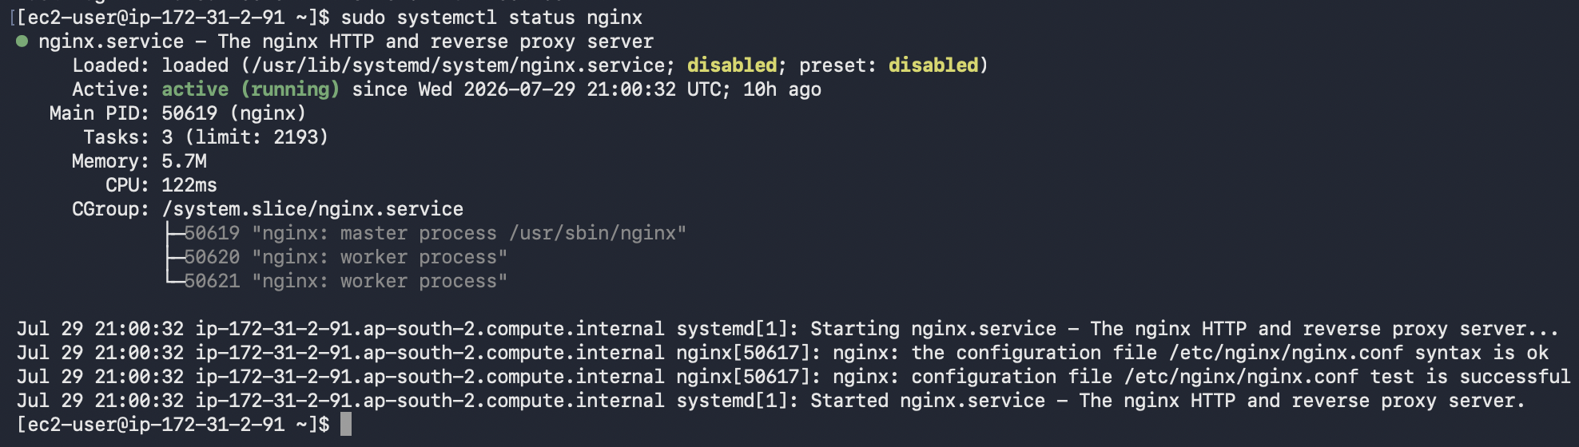

Step 2: Update the CloudWatch Agent Configuration
- Run the following commands
  - sudo nano /opt/aws/amazon-cloudwatch-agent/etc/amazon-cloudwatch-agent.json
  - Update the procstat section so it monitors both Tomcat and Nginx or replace the whole json content with below json
  - {
"agent": {
"metrics_collection_interval": 60
},
"metrics": {
"namespace": "CWAgent",
"metrics_collected": {
"procstat": [
{
"pattern": "tomcat",
"measurement": [
"pid_count"
]
},
{
"pattern": "nginx",
"measurement": [
"pid_count"
]
}
]
}
}
}
  - Save the file.

Step 3: Reload the CloudWatch Agent
- Run the following commands
  - sudo /opt/aws/amazon-cloudwatch-agent/bin/amazon-cloudwatch-agent-ctl \
-a fetch-config \
-m ec2 \
-c file:/opt/aws/amazon-cloudwatch-agent/etc/amazon-cloudwatch-agent.json \
-s
  - Verify the agent is still running - sudo /opt/aws/amazon-cloudwatch-agent/bin/amazon-cloudwatch-agent-ctl -a status
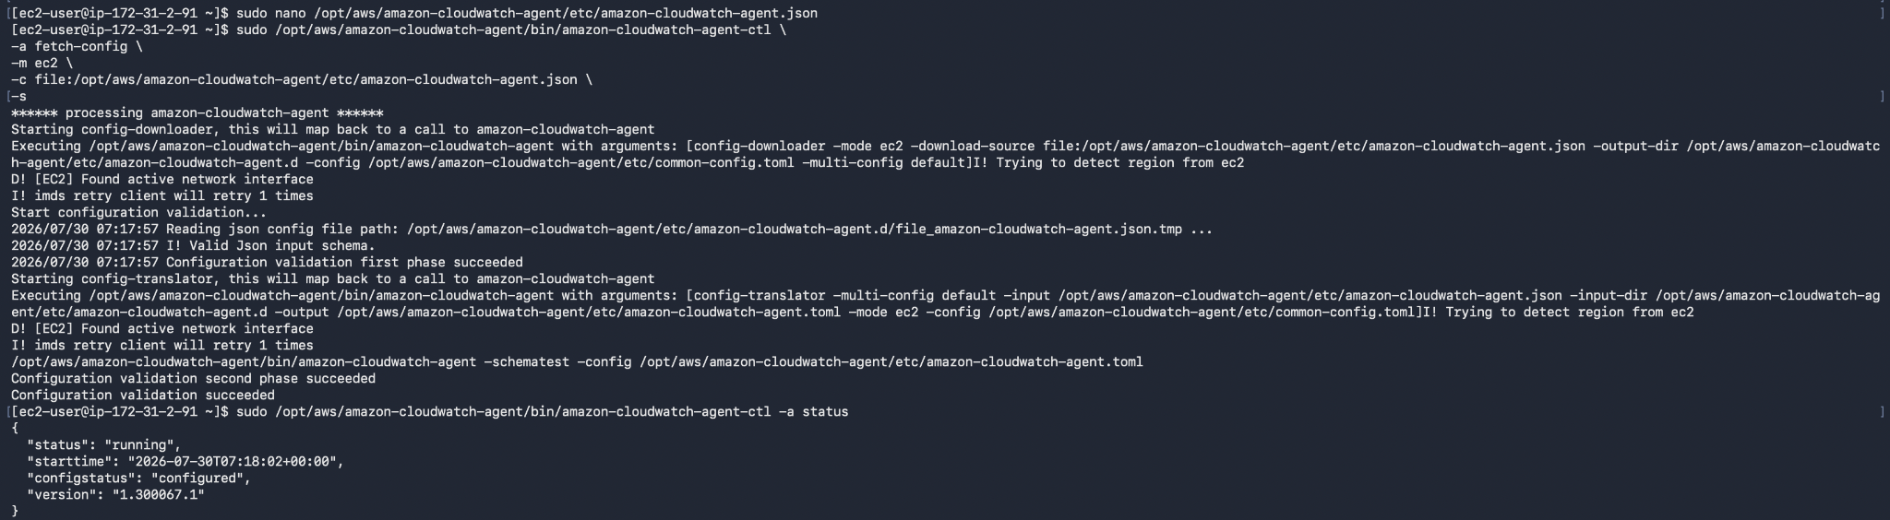

Step 4: Verify the Nginx Metric
- Open CW -> Classic Metrics -> All -> CW Agent -> procstat
  - You’ll be able to see 2 process metrics
    - Tomcat
    - Nginx
  - Select the metric for the Nginx process.
  - If procstat_lookup_pid_count = 1, then nginx is running.
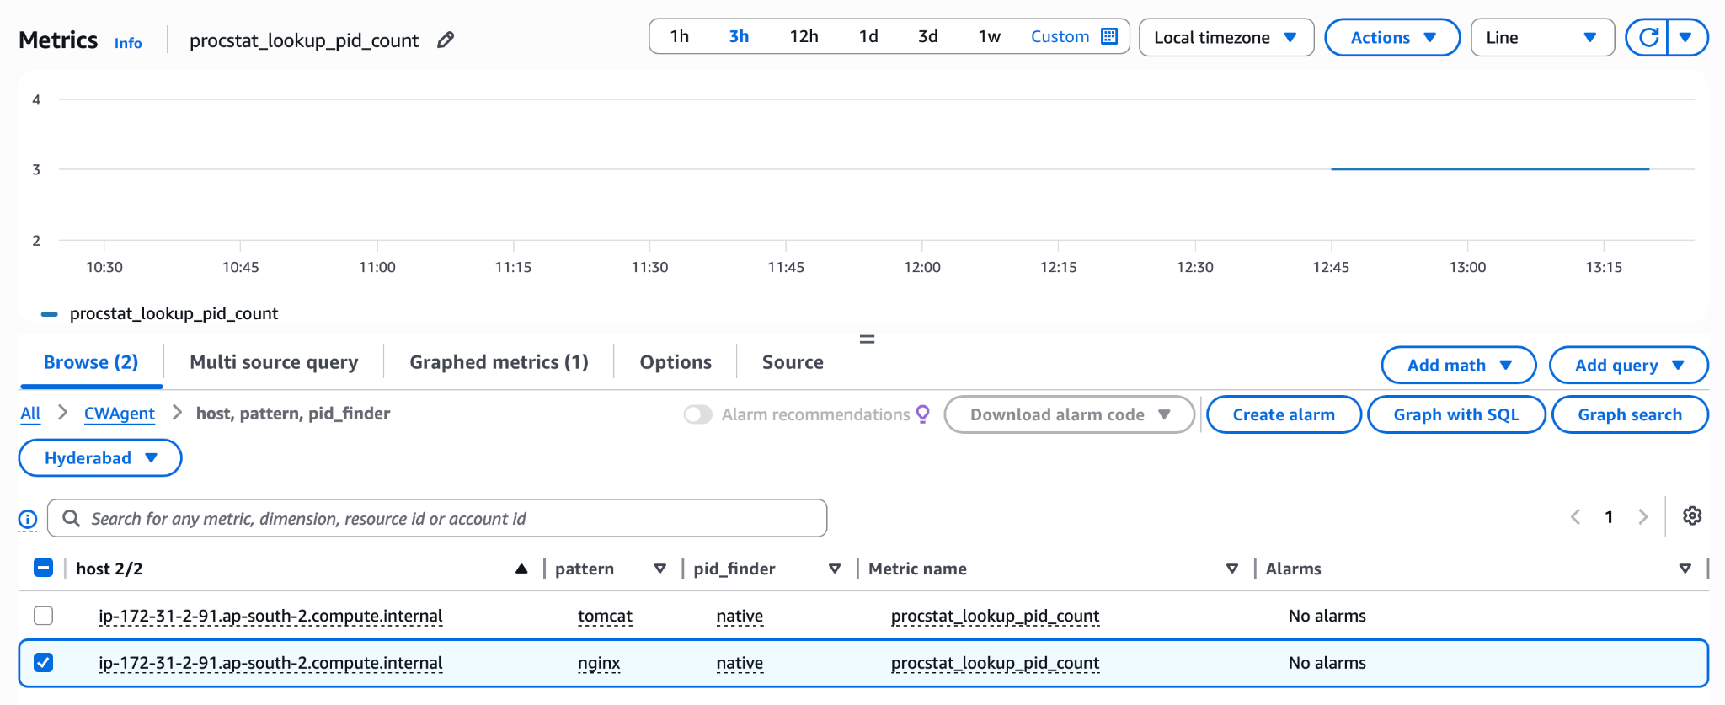
Step 5: Create the Dashboard
- Open CW -> Dashboards -> Create new Dashboard
  - Name: Nginx-Monitoring-Dashboard
  - Metric: CWAgent -> procstat -> procstat_lookup_pid_count (Nginx)
  - Widget: Line
  - Click ‘Save’
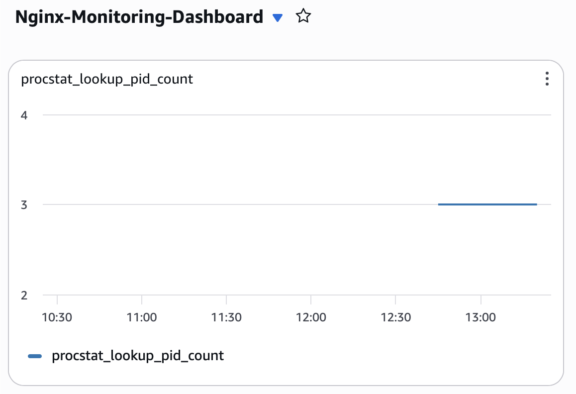

Step 6: Create the Alarm
- Cloud Watch -> Alarms-> Create Alarms
  - Select CW Agent -> procstat_lookup_pid_count
  - Configure like this…
Setting | Value
Statistic | Average
Period | 1 minute
Threshold | Less than 1
Evaluation Periods | 1
SNS Topic | Existing SNS Topic
Alarm Name | Nginx-Service-Down

  - Review & Click ‘Create Alarm’
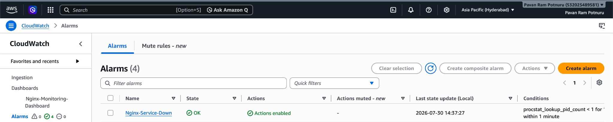
Step 7: Test the Alarm
- Run the following commands
  - Stop the service - sudo systemctl stop nginx
  - Wait for 5mins
  - You’ll receive an email acknowledging the down-time
  - Now again start the service - sudo systemctl start nginx
